**Cairo University Faculty of Computers and Artificial Intelligence**

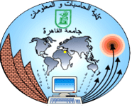

**Software Design and Architecture**

**Software design specification document**

**2021**

**Project Team**

|  |  |  |  |
| --- | --- | --- | --- |
| **ID** | **Name** | **Email** | **Mobile** |
| 20180054 | Omneya Eid Mohamed | omneyaeid827@gmail.com | 01060846630 |
| 20180044 | Islam Ramadan Abdu | islamramadan345543@gmail.com | 01118405750 |
| 20180211 | Mahasen Mohamed Ahmed | mahasenmohamed290@gmail.com | 01123658923 |

**Eng. Esraa Abbas**

**Contents**

Class diagram design 2

Sequence diagram design 3

Github repository link 5

# Class diagram design

# Sequence diagram design

Refactor booking

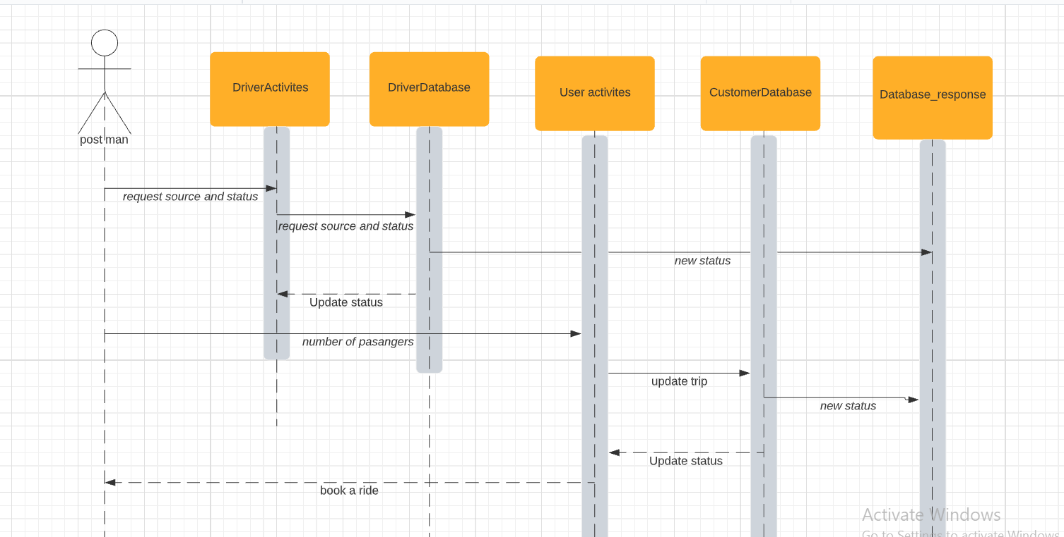

Show the events that happened on specific rides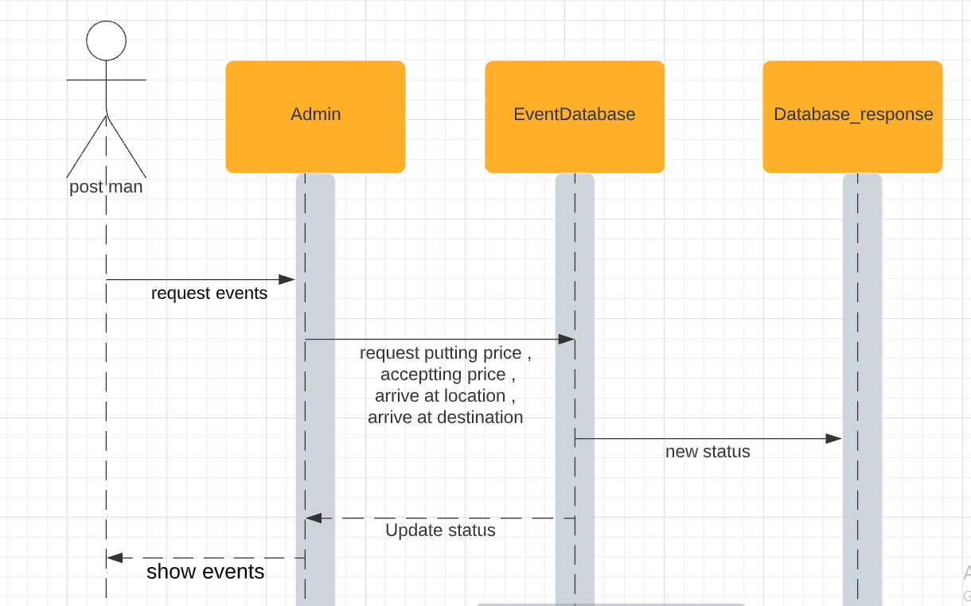

add discounts on specific areas

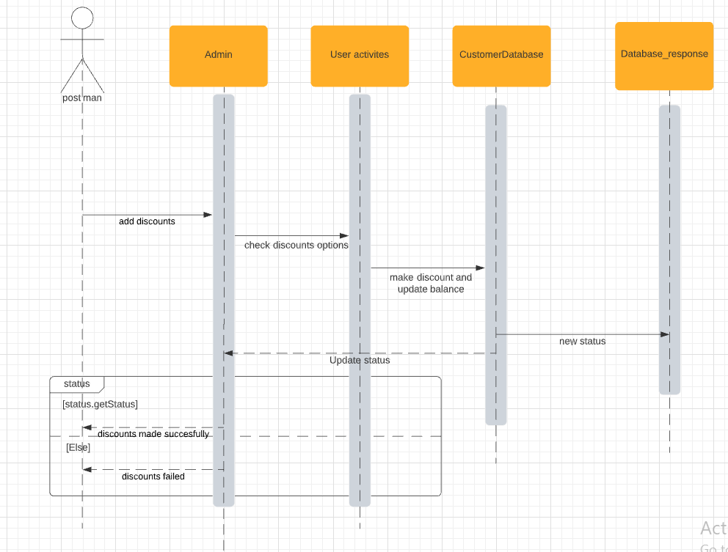

**Github repository link**

* https://github.com/islamramadanabdo/DriverSW